**Description of Dataset and Goal-Setting**

The dataset was records of service requests initiated by LA residence to 311 call center, the center responsible for miscellaneous municipal service requests. Our key goals of this analysis project include:

* Identify and visualize overall trends and patterns of service requests
* Identify key issues faced by 311, design a Key Performance Indicator (KPI), and identify best and worst performing cases
* Provide improvement recommendations to worst performing cases
* Develop an online monitoring tool in Shiny to facilitate and improve 311 team’s future work flows

**Distribution of Request Type**

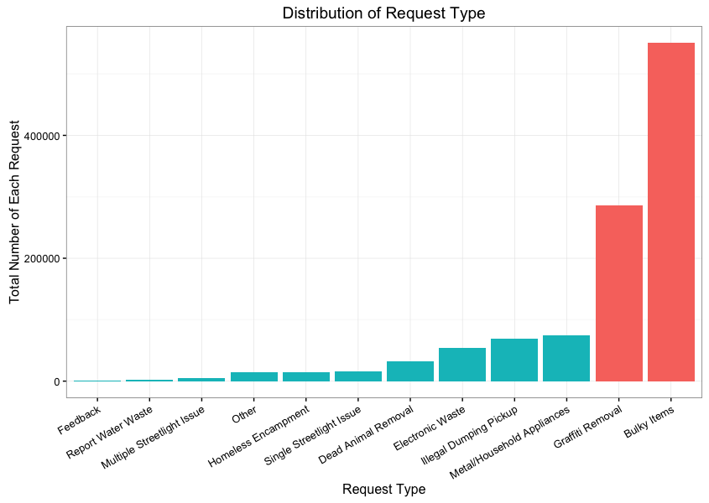

Upon receiving the dataset, we wanted to get an idea of what types of request are most common, and will focus on the top requests throughout the rest of our analysis. Thus, we created a ggplot2 bar chart, showing the total number of each request type. As shown on the graph, Bulky Items and Graffiti Removal represent the majority of the request with

more than 80% among all request types. Thus, we decided to focus our analysis on the top 3 types: Bulky Items, Graffiti Removal, and Metal/Household Appliances.

**Distribution of Assigned Departments**

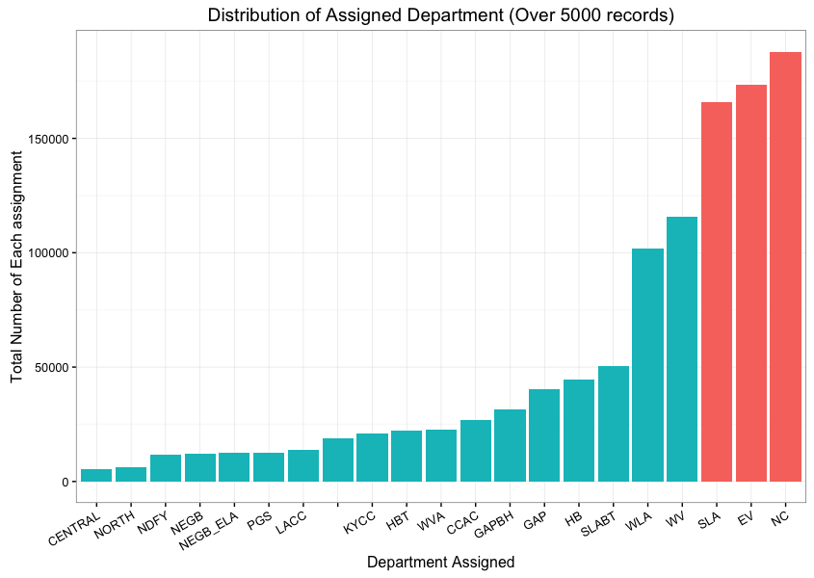

Next, we looked into the distribution of assigned departments. As can be seen from the graph, the distribution is highly skewed, with NC, EV, and SLA assigned to the majority of the cases. We do not know the levels of resources behind each department, so we cannot say in certainty that there is imbalance of workload across departments, but we would recommend 311 to reevaluate the labor + capacity allocation among these departments. In addition, some of the departments may overlap in function, some may overlap in geographic, hence there may be cross-departmental work assignment opportunities to further optimize the overall performance. We will further conduct analysis on that.

**Top Five Request Sources**

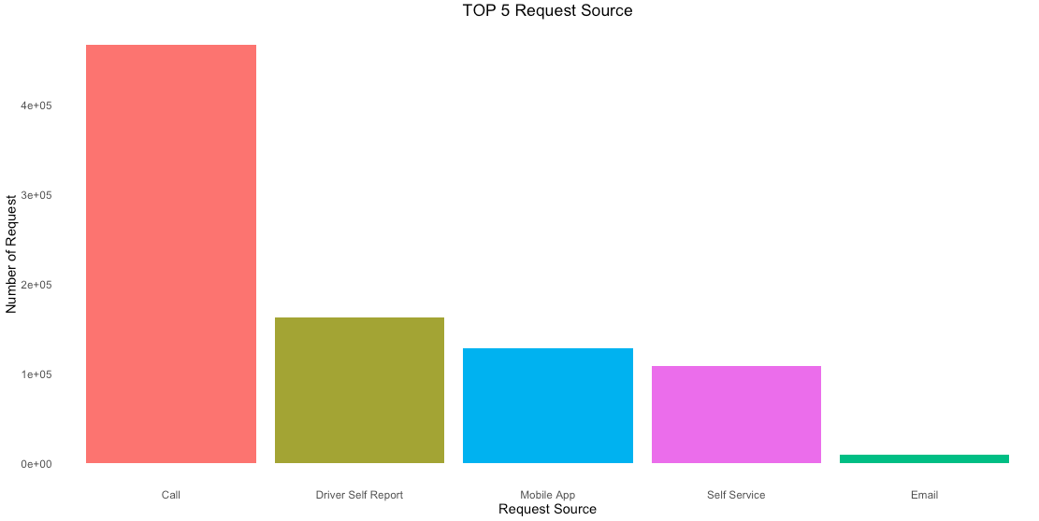Next, we looked into what the top 5 request sources are. Using ggplot2, we identified Call, Driver Self Report, Mobile App, Self Service, and Email are the top 5 request sources. Phone calls remain the primary way of requesting. Since calling is the most labor intensive way of handling service requests and may hinder call center’s work flow efficiency, and mobile app can be a good supplement, we wanted to run an overall trend on requests made via calls vs. apps. Below is the result.

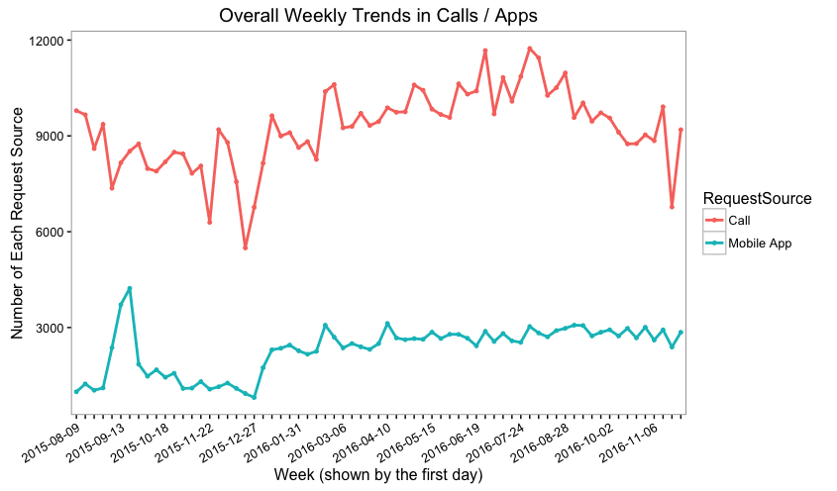

As can be seen from the graph, requests made via phone calls have been going up and down during the last three months, and have been remaining at around 9000 per week. On the other hand, number of requests made via mobile apps has been remaining at around 3000. The declines and increases of both appear to be synced, indicating that the drops may be caused by drops in overall number of requests. There is no obvious increasing or decreasing trend on this graph, indicating that we are not seeing more users adopting the mobile app reporting method, although it may be more efficient for both the caller and the call center. We recommend 311 to conduct analysis on callers and understand what are the main drivers behind calling vs. using app, and actively promote the use of mobile app.

**Heatmap of Requests Breakdown by Weekday and Hour**

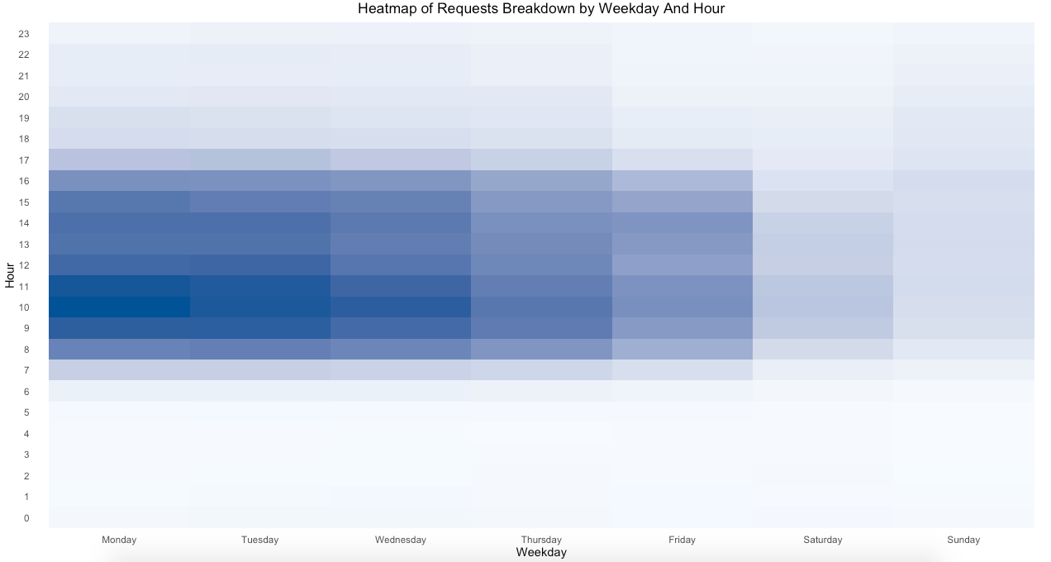

To further understand ways to improve call center’s efficiency, we then developed a heatmap of number of requests breakdown by weekday and hour. It is obvious that most of the requests are during work hours on weekdays. This is because the call center is only open during these timeframes. We also found that requests tend to be most between 9 and 11 am on Mondays thru Wednesday. We recommend 311 to allocate its staffing according to this heatmap, and consider extending its service hours further into the mornings and evenings so that peaks can be eased. We understand labor cost is a major concern for a municipal service organization, but we believe we will achieve a balance of cost and efficiency if we can allocate staffing flexibly.

**Top 3 Request Types of Significant Sources**

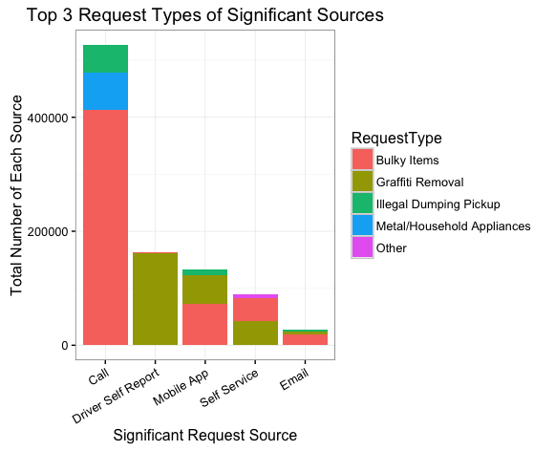

We then created a ggplot2 bar chart highlighting the composition of request types per significant request source. We found that the majority of calls are related to bulky items, while the absolute majority of driver self-report is related to graffiti removal. To improve call center’s efficiency in dealing with bulky items requests, we recommend 311 to consider adopting a default transfer option for automatically transfer calls from top bulky items areas to a bulky item specialist, who can more efficiently handle the service requests. Similarly, for graffiti removal, we recommend 311 to look into ways to automatically handle driver self-report with graffiti removal as a default option.

**Trends of Top Requests Per District**

Next, we plotted a multi-facet line chart of average number of requests overtime for the top 3 types requests (bulky items, graffiti removal, and metal/household appliances). The red lines represent averages across districts, and the black lines represent district-level performance.

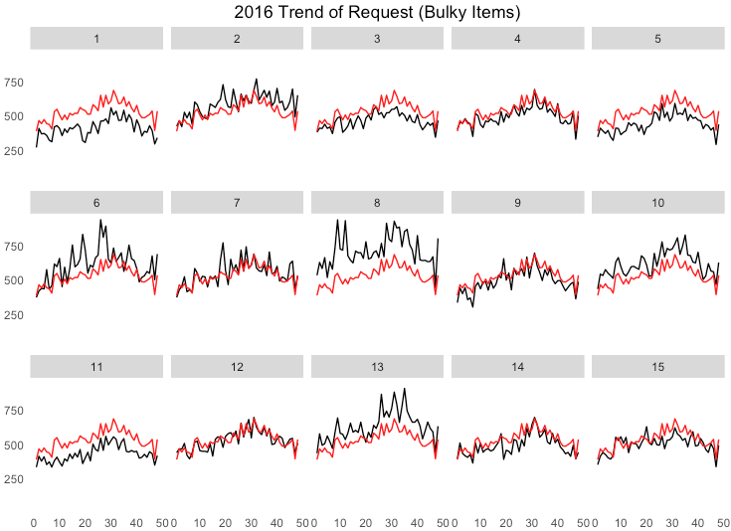

As we can see, for bulky items, district 6, 8, and 13 perform worse than the district average.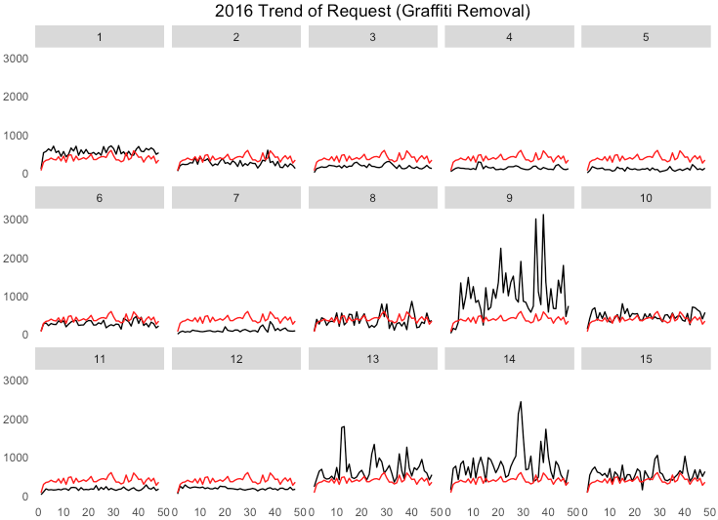

For graffiti removals, district 9, 13, and 14 performed way worse than average. Especially district 9 has dramatically higher averages throughout the 3-month period. Also, we noticed that magnitude of variance for district 9 is way higher than any of the other districts.

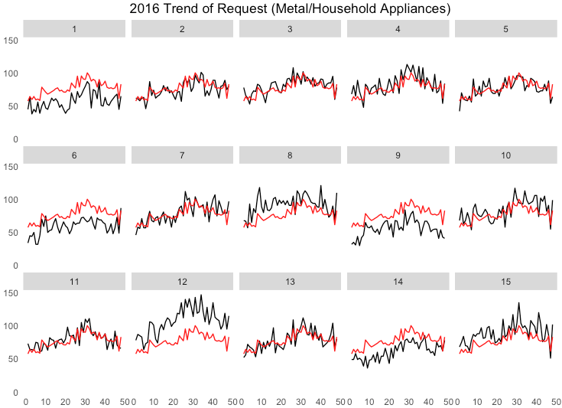  
For Metal/Household Appliances, we’ve identified district 8 and 12 as the obvious worse performers.

Through visualizing district level performances, 311 can focus on certain districts with poorer performances and spend more resources in root causing and proactively manage the incidents.

**Development of a KPI and Shiny Tool**

Throughout our analysis and as a consulting group servicing the 311 call center, we realized that there are multiple facets to consider when evaluating district performance, and it is important to define a key performance indicator (KPI) with important parameters in consideration, and develop an interactive tool/dashboard which can be deployed by 311 to easily monitor and track performance. Through group discussion and research, we’ve decided to create a KPI “District Inconvenience Index”, which is a composite of total number of requests, duration of service times, and population density (population/district area). Through creating such KPI, we can identify poor performing districts and focus on improving our service in that area. Districts with High number of requests, High population density, and Long service duration will be highlighted and considered poor performance districts.

Using the most recent 3-month data, we have identified below districts with high Inconvenience Index:

* District 10 (Bulky Items)
* District 9 (Graffiti Removal)
* District 12 (Metal/Household)

After defining the KPI, we then worked on creating a Shiny tool that can dynamically track district performance and highlight districts based on certain filtering criteria. Below are demo screenshots of the product. We will demonstrate it during our class presentation, and hopefully, this can be further developed and deployed by 311 in order to improve the quality and efficiency of their service to the citizens.

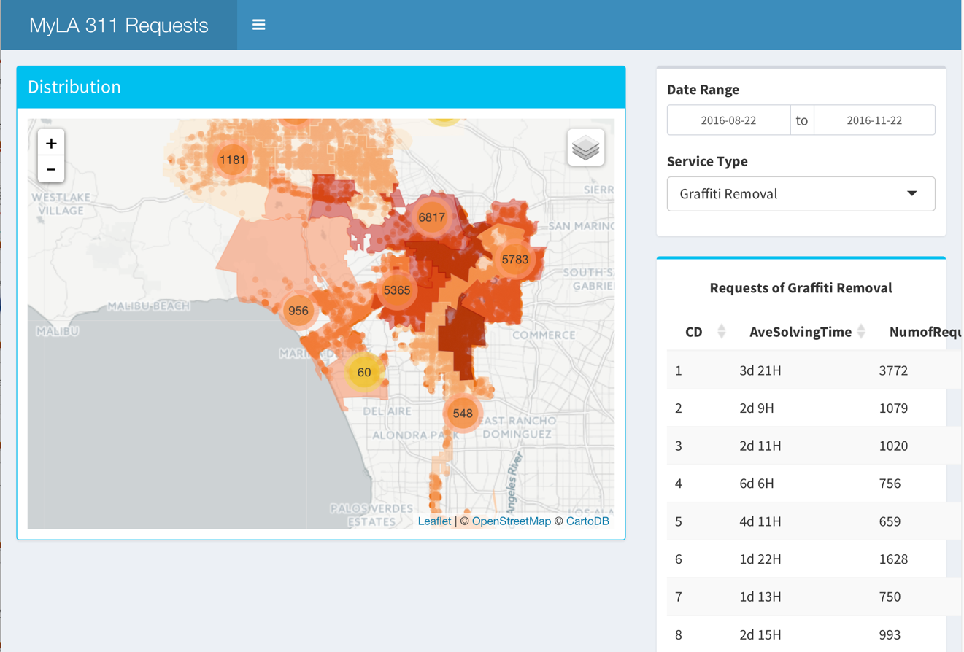

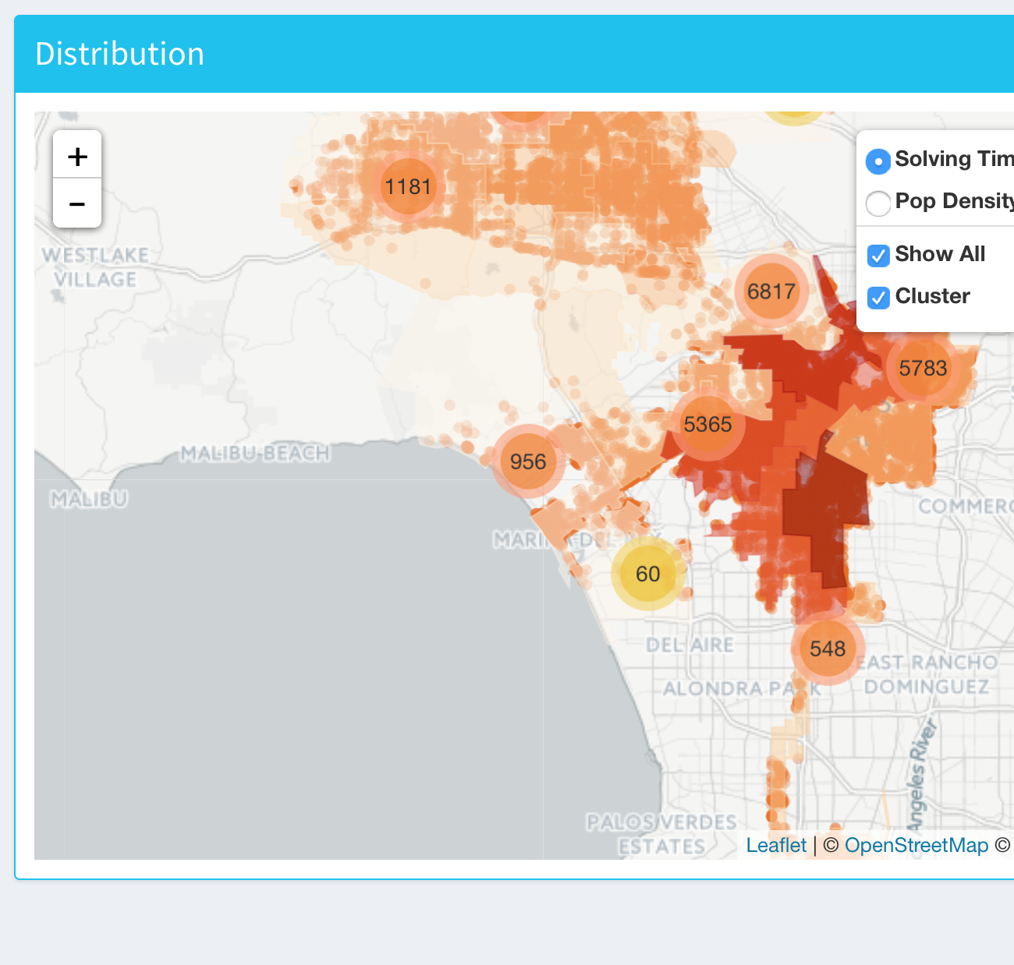

**Conclusion and Next Steps**

Our research has been focusing on visualizing trends of municipal service requests, analyzing service performance, and making recommendations to improve work flow efficiency. Through analysis, we have realized that there are multiple aspects to service performance. Thus, we developed a KPI to measure service performances, and have identified districts that may need assistance in improvements. Further, we have developed a prototype real-time tracking dashboard in Shiny to assist 311 to monitor and analyze district level information. Moving forward, we would love to continue working on the dashboard to include more useful information in addition to the KPI. Also, we realized that the dataset provided was only for 311 call center, and we do not have customer-level detail information, or how capacity and resources are being managed by assigned departments. We recommend 311 to reach out to other key stakeholders in the value chain, and collaborate on a data analysis for the whole value chain. With complementary information added, we believe we will provide more useful information to all parties involved.